MODELO CONCEITUAL

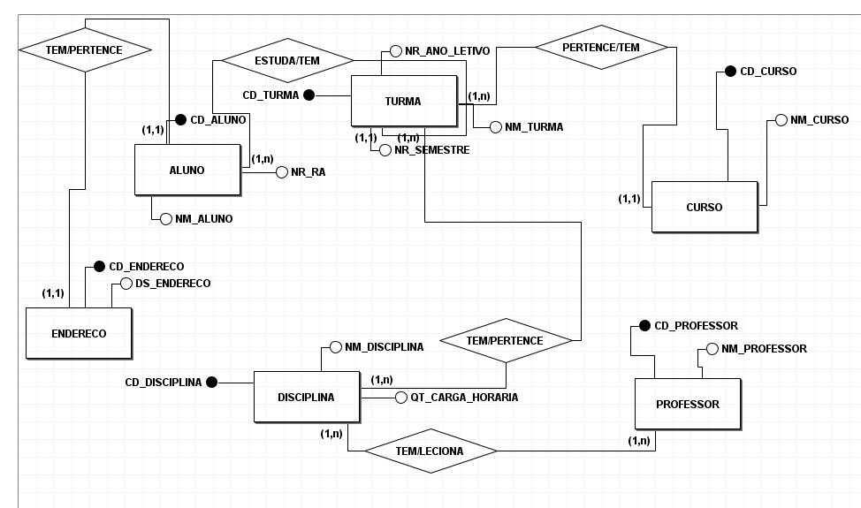

MODELO LÓGICO

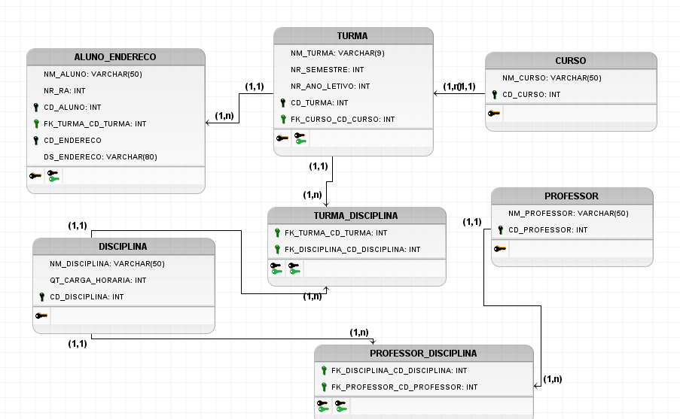

--DDL DATA DEF LANGUAGE

CREATE DATABASE ESCOLA;

USE ESCOLA

--CRIAR TABELA

CREATE TABLE CURSO

(CD_CURSO INT IDENTITY(1,1) PRIMARY KEY NOT NULL,

NM_CURSO VARCHAR(50) NOT NULL,

CONSTRAINT UNICO_CURSO UNIQUE(NM_CURSO))

INSERT INTO CURSO VALUES (1,'ADS') -- ERRO DE PK

INSERT INTO CURSO VALUES ('ADS')

INSERT INTO CURSO VALUES ('TJD')

SELECT * FROM CURSO

INSERT INTO CURSO VALUES ('BSI'),('GTI'),('BCC')

CREATE TABLE TURMA

(CD_TURMA INT IDENTITY NOT NULL,

NM_TURMA CHAR(9) NOT NULL,

NR_SEMESTRE INT NOT NULL,

NR_ANO_LETIVO INT NOT NULL,

CD_CURSO INT NOT NULL,

CONSTRAINT PK_TURMA PRIMARY KEY(CD_TURMA),

CONSTRAINT FK_TURMA FOREIGN KEY(CD_CURSO) REFERENCES CURSO(CD_CURSO))

--DML

SELECT * FROM CURSO

INSERT INTO TURMA VALUES ('048104A16',1,2021,1)

INSERT INTO TURMA VALUES ('048103A16',1,2021,1)

INSERT INTO TURMA VALUES ('048105A16',1,2021,1)

INSERT INTO TURMA VALUES ('048101A16',1,2021,1)

INSERT INTO TURMA VALUES ('019104A16',1,2021,2)

INSERT INTO TURMA VALUES ('019103A16',1,2021,2)

INSERT INTO TURMA VALUES ('019105A16',1,2021,2)

INSERT INTO TURMA VALUES ('108103A16',1,2021,3)

INSERT INTO TURMA VALUES ('108105A16',1,2021,3)

INSERT INTO TURMA VALUES ('179204A16',1,2021,3)

SELECT * FROM CURSO

SELECT * FROM TURMA

SELECT * FROM CURSO AS C,TURMA AS T WHERE C.CD_CURSO=T.CD_CURSO

SELECT * FROM CURSO C INNER JOIN TURMA T ON C.CD_CURSO=T.CD_CURSO

SELECT * FROM CURSO C LEFT JOIN TURMA T ON C.CD_CURSO=T.CD_CURSO

SELECT * FROM TURMA T RIGHT JOIN CURSO C ON C.CD_CURSO=T.CD_CURSO



SELECT * FROM FUNCIONARIO AS F

INNER JOIN CIDADE AS C ON C.CIDADEID=F.CIDADEID

INNER JOIN ESTADO AS E ON E.ESTADOID=C.ESTADOID

INNER JOIN TELEFONE_FUNCIONARIO AS TF ON F.FUNCIONARIOID=TF.FUNCIONARIOID

INNER JOIN TELEFONE AS T ON T.TELEFONEID=TF.TELEFONEID

INNER JOIN DEPTO AS D ON D.DEPTOID=F.DEPTOID

SELECT NM_FUNCIONARIO,SALARIO,SEXO,NM_CIDADE,UF,DDD,TELEFONE,NM_DEPTO

FROM FUNCIONARIO AS F

INNER JOIN CIDADE AS C ON C.CIDADEID=F.CIDADEID

INNER JOIN ESTADO AS E ON E.ESTADOID=C.ESTADOID

INNER JOIN TELEFONE_FUNCIONARIO AS TF ON F.FUNCIONARIOID=TF.FUNCIONARIOID

INNER JOIN TELEFONE AS T ON T.TELEFONEID=TF.TELEFONEID

INNER JOIN DEPTO AS D ON D.DEPTOID=F.DEPTOID

ORDER BY NM_DEPTO,NM_CIDADE

SELECT NM_FUNCIONARIO,SALARIO,SEXO,NM_CIDADE,UF,DDD,TELEFONE,NM_DEPTO

FROM FUNCIONARIO AS F

INNER JOIN CIDADE AS C ON C.CIDADEID=F.CIDADEID

INNER JOIN ESTADO AS E ON E.ESTADOID=C.ESTADOID

INNER JOIN TELEFONE_FUNCIONARIO AS TF ON F.FUNCIONARIOID=TF.FUNCIONARIOID

INNER JOIN TELEFONE AS T ON T.TELEFONEID=TF.TELEFONEID

INNER JOIN DEPTO AS D ON D.DEPTOID=F.DEPTOID

WHERE NM_DEPTO = 'RH'

ORDER BY NM_CIDADE